**Perseverance Track Club Daytona Application Form**

**Demographic Information**

Athlete’s name: ____________________________________________________________

Athlete’s Date of Birth: ________________________________________________________

Athlete’s Gender:

* Male
* Female

Address: ______________________________________________________________________

Telephone number: ______________________________________________________________

Parents / Guardian: ______________________________________________________________

**Uniform Size**

Shirt Size:

* Youth XS
* Youth Small
* Youth Medium
* Youth Large
* Youth XLarge
* Adult XS
* Adult Small
* Adult Medium
* Adult Large
* Adult XLarge

Girls Sizing Chart for Uniform. Please indicate sizes for top and bottom.

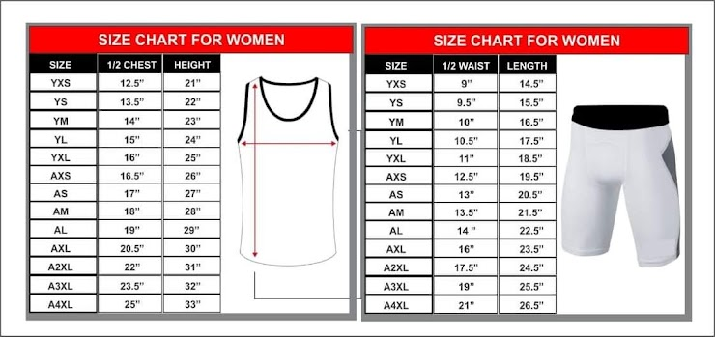

Your answer

Boys Sizing chart for Uniform. Please indicate size for top and bottom.

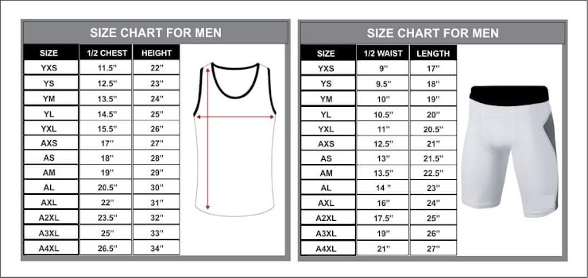

Your answer

Please send a copy of this application to perseverancetrackclubdaytona@gmail.com